PROJECT REPORT
ON
JUNGLE TUNE
Submitted in the partial fulfilment of the requirement for the award of degree of
BACHELOR OF TECHNOLOGY
IN
COMPUTER SCIENCE AND ARTIFICIAL INTELLIGENCE
(2022-2026)


Submitted to: Submitted by: Ms. Sangeeta Bhatti Prince
12200813
B.Tech(CS&AI)
CSE400A
DEPARTMENT OF COMPUTER SCIENCE AND ENGINEERING
DAV UNIVERSITY
JALANDHAR-PATHANKOT NATIONAL HIGHWAY,NH 44,
SARMASTPUR PUNJAB, 144012

CERTIFICATE
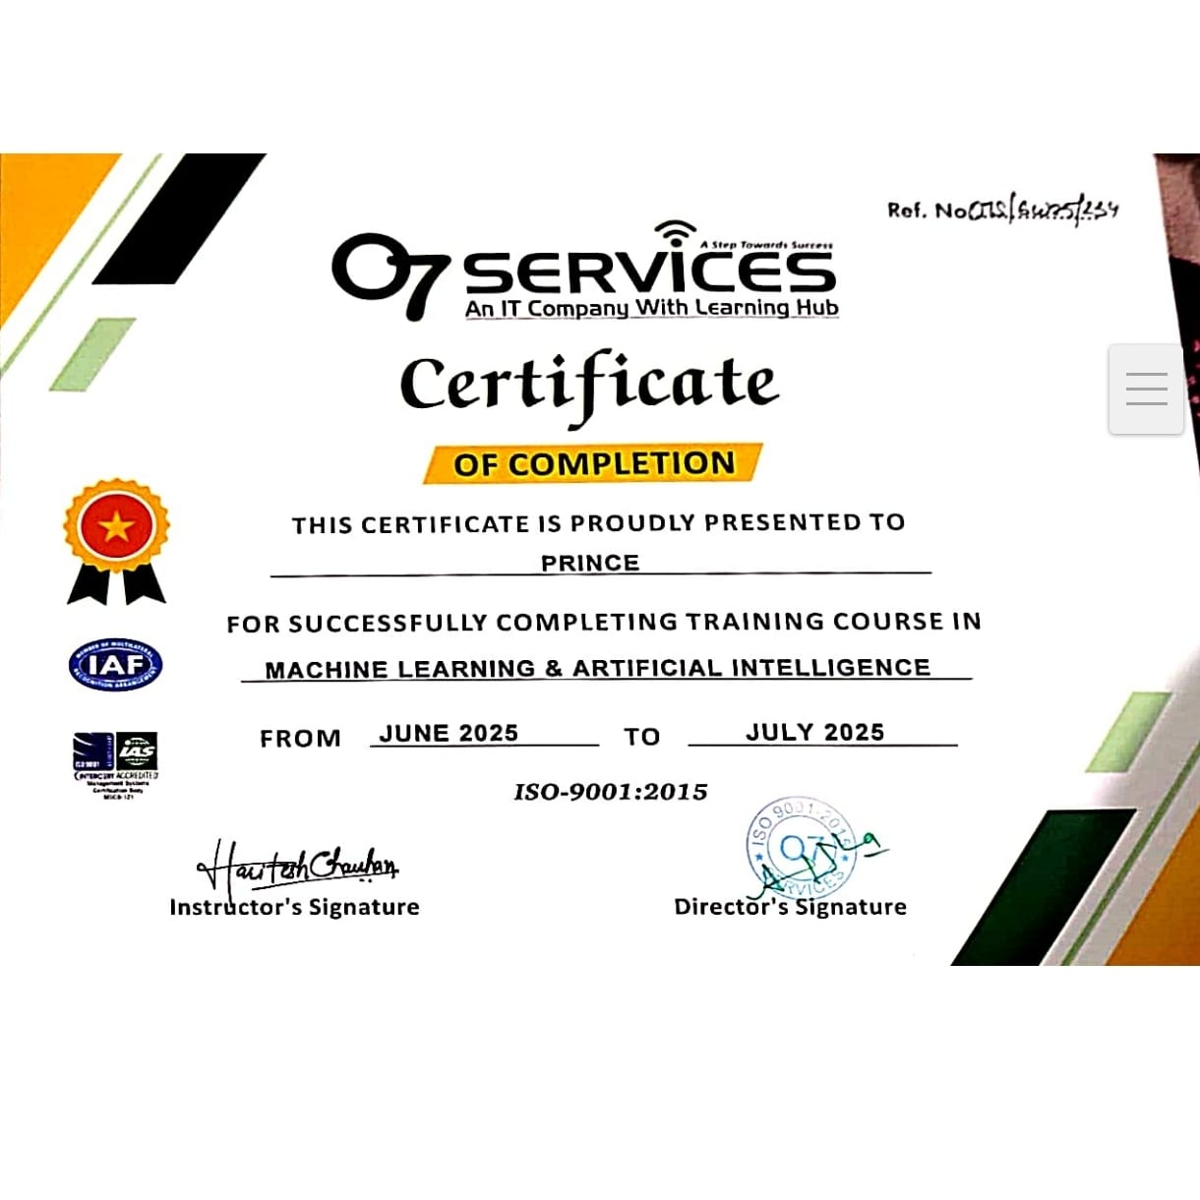

CERTIFICATE
This is to certify that Ms.PRINCE D/O JAGDISH RAI(Student of DAV UNIVERSITY, JALANDHAR) has partially completed the 6 Weeks Industrial Training during the period from June 2025 to August 2025 in our Organization/Industry as a Partial Fulfillment of Degree of Bachelor of Technology in Computer Science& Artificial Intelligence.

DAV UNIVERSITY,JALANDHAR

DECLARATION
I,Prince,hereby declare that the Industrial Training Report entitled(“JUNGLE TUNE”) is an authentic record of my own work as requirements of 6-weeks industrial Training during the period from June 2025 to August 2025 for the award of degree of B.TECH (COMPUTER SCIENCE AND ARTIFICIAL INTELLIGENCE ) under the guidance of (MR.HARITESH CHAUHAN).
Prince
(12200813)

ABSTRACT
Automatic classification of animal vocalizations is an emerging field at the intersection of bioacoustics and machine learning, with significant implications for biodiversity monitoring, species identification, behavioral research, and conservation efforts. Traditional methods for analyzing animal sounds are often labor-intensive and rely heavily on expert knowledge, making them inefficient for processing large-scale acoustic data. This study presents a machine learning-based approach to the classification of animal sounds, aiming to automate and enhance the accuracy of species identification from audio recordings.
Preprocessing techniques such as noise reduction, audio segmentation, and normalization are applied to improve data quality. Feature extraction is performed using Mel-Frequency Cepstral Coefficients (MFCCs), chroma features, spectral contrast, and log-Mel spectrograms, capturing both temporal and spectral characteristics of the sounds.
Multiple machine learning models are implemented and evaluated, including traditional classifiers such as deep learning architectures like Convolutional Neural Networks (CNNs) and Long Short-Term Memory (LSTM) networks. The models are trained and validated using cross-validation techniques, and performance is measured in terms of classification accuracy, precision, recall, and F1-score.Our findings indicate that deep learning models, particularly CNNs applied to spectrogram representations of animal calls, significantly outperform traditional methods, achieving high classification accuracy across various species. Furthermore, the use of data augmentation and transfer learning techniques proves beneficial in handling limited labeled data and improving model generalizability
Key Steps:
- Objective: To classify animal sounds based in audio inputs using ML/DL techniques.
- Motivation: Helpful in wildlife monitoring, biodiversity research, detecting animal present in farm and forest.
- Dataset: Audio recordings of various animals,preprocessed and labelled for training.
- Preprocessing: Conversion of audio signals into features like MFCCs(Mel-Frequency Cepstral Coefficients), Spectrograms ,etc.
- Model Used: ML models such as CNNS,ANNS models for audio classification.
- Training & Evaluation: Dataset split into training and testing sets,model evaluated on accuracy,precision and recall.
- Results: The trained model can classify different animal species based on their sound with their class names.
ACKNOWLEDGEMENT
I express my gratitude to all those who helped us in various stages of the development of this project. First,I would like to express my sincere gratitude indebtedness to DR.Rahul Hans (Coordinator) of DAV University for allowing me to undergo the summer training of 45 days at .I am also thankful to all faculty members of Department of Computer Science and Engineering,for their true help, inspiration and for helping me for the preparation of the final report and presentation.
Last but not least,I pay my sincere thanks and gratitude to all the Staff Members of for their support and for making our project valuable and fruitful.

COMPANY PROFILE

O7 Services is ISO 9001:2015 Certified company founded in 2015. They specialise in a variety of services including Web Development, Mobile Application Development, Custom Software Development, UI/UX Designing, Hosting services, Digital Marketing, Registration of Domain Names with various extensions, AMC & MMC Services, Bulk SMS and voice calls. O7 Services offers advanced IT solutions supporting the entire business cycle - from consulting to system development, deployment, quality assurance, and 24x7 support. With over 9 years of experience, the company aims to form long-lasting strategic partnerships with clients, offering affordable prices, timely delivery, and measurable business results. Their headquarter is located in Jalandhar with a branch office in Hoshiarpur.
Some of the products developed by O7 Services include Vehicle Tracking System, Invoice Software, School Management System, Hospital Management System, Parents - Teacher Communication App, Fee Management system, Task Management System, Online Food Ordering App, Security App, Admission system, Inventory Software, and Car Servicing App. Additionally, O7 Services provides training programs including 6 Weeks/6 Months Industrial Training.
Project-Based Training, Corporate Training, and Job-Oriented Courses Training, covering major IT trends such as Full Stack Development (MEAN/MERN), Flutter, Kotlin Android, Swift UI (iOS), Firebase, Python, Angular, React Js, Vue Js, Node Js, ASP.NET,.NET Core, PHP, Laravel, CodeIgniter, Software Testing, Cloud Computing, Blockchain, DevOps, Data Science, Artificial Intelligence, Machine Learning, UI/UX Designing, Digital Marketing, WordPress, Linux, CCNP, CCNA Security, Network Security, Cyber Security, MCSE, MCITP, Java, Spring, Hibernate, C/C++, Photoshop, Adobe Illustrator, Figma, CorelDraw and many more.
+91- 8437365007, +91-181-5015007
E-Mail: enquiry@o7services.com , hr@o7services.com
www.o7services.com

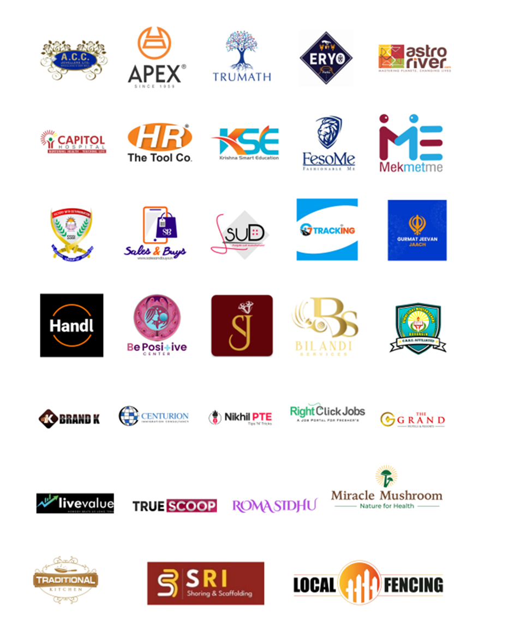

TABLE OF CONTENTS
Sr.No | Content | Page No.
1. | Introduction: | 1-2
 | 1.1 Problem Defintion
 | 1.2 Objectives
2. | Data Preprocessing | 3-5
 | 2.1 Steps in Preprocessing
3. | Exploratory Data Analysis | 6-7
4. | Requirement Analysis | 8-11
 | 4.1 Types of Feasibility Study
 | 4.2 SDLC Model
5. | System Requirement Specification | 12-14
 | 5.1 Need of System Requirement Specification
 | 5.2 Resources Needed
 | 5.3 Tool Used
6. | Data Flow Diagrams (DFD’s) | 15-16
7. | Tools, Technologies and Libraries | 17-24
 | 7.1 Technologies
 | 7.2 Libraries
 | 7.3 Tools
8. | Implementation, Testing and Maintenance | 25-28
 | 8.1 Implementation
 | 8.2 Testing
 | 8.2.1 Developing the Test Plan
 | 8.2.2 Types of Testing
 | 8.2.3 Test Planning
 | 8.2.4 Test Design
 | 8.3 Maintenance
9. | Screenshots | 29-30
10. | Conclusion and Future Scope | 31
11. | Bibliography | 32

CHAPTER-1
INTRODUCTION
Sound plays a crucial role in the communication and behavior of animals across species. Vocalizations can signal mating readiness, mark territory, convey alarm, or maintain group cohesion. Monitoring and identifying these vocalizations is vital in fields such as wildlife ecology, bioacoustics, conservation biology, and animal behavior research.
Traditionally, the classification of animal sounds has relied on manual listening and annotation by experts a time-consuming and error-prone process that is not scalable for large datasets or real-time applications.
In recent years, advances in machine learning (ML) and digital signal processing have made it possible to automate the process of sound classification. By transforming raw audio signals into meaningful features and training models to recognize patterns in these features, machine learning systems can learn to distinguish between different species or types of calls with high accuracy.
These systems have the potential to operate in real-time, monitor vast areas using acoustic sensors, and contribute to non-invasive wildlife monitoring techniques.
However, developing accurate and robust ML models for animal sound classification presents several challenges. Animal vocalizations can vary greatly between individuals, habitats, and environmental conditions. Audio recordings often contain background noise, overlapping sounds, or incomplete calls. Moreover, datasets are often imbalanced, with fewer recordings for rare or endangered species.
To address these challenges, a typical sound classification pipeline involves several key stages: data collection, data cleaning, feature extraction, model training, and evaluation. Feature extraction techniques such as Mel-Frequency Cepstral Coefficients (MFCCs), spectrograms, and chroma features are used to convert audio into formats suitable for machine learning algorithms.
Models such as Support Vector Machines (SVMs), Random Forests, and deep learning architectures like Convolutional Neural Networks (CNNs) and Recurrent Neural Networks (RNNs) can then be trained to classify these sound.

1.1 PROBLEM DEFINITION
The problem addressed in this project is the automatic identification and classification of animal species based on their vocalizations using machine learning techniques. In many wildlife monitoring and farm management scenarios, manual identification of animal sounds is time-consuming, error-prone, and impractical, especially in remote or large-scale environments.
This project aims to develop a machine learning-based model that can process raw audio recordings of animal sounds, extract relevant features, and accurately classify them into predefined animal categories.
1.2 OBJECTIVE

The primary objective of this study is to develop and evaluate machine learning models capable of accurately classifying animal vocalizations based on audio recordings.
1.Collecting and preprocessing a diverse dataset of animal sounds from various sources. Cleaning and transforming the raw audio into standardized, feature-rich formats.

2. Extracting relevant audio features that capture the temporal and spectral characteristics of animal vocalizations.

3. Training and testing multiple machine learning models to identify the most effective approach for sound classification.

4. Apply ML algorithms like Decision tree, CNN for comparing model performance using standard evaluation metrics such as accuracy, precision, recall and F1-score.

5. Model Evaluation:
- Test on unseen audio.
- Check for overfitting/Underfitting.
6. Deployment
- Create a user interface using Streamlit.

CHAPTER-2
DATA PREPROCESSING

Data preprocessing is the process of preparing raw data for analysis by cleaning and transforming it into a usable format.
To prepare raw animal vocalization audio data for input into machine learning models by cleaning, standardizing, segmenting, and extracting meaningful features.
- Goal is to improve the quality of the data.
- Helps in handling missing values, removing duplicates, and normalizing data.
- Ensures the accuracy and consistency of the dataset.

2.1 Steps in Data Preprocessing

1. Audio Collection and Labeling
Gather relevant data from various sources such as animal voice data from kaggle ,bird chirping sound . This can include
- Source: Collect audio samples from publicly available datasets (e.g., Macaulay Library, Xeno-Canto, or custom field recordings,kaggle ).
- Labeling: Ensure each audio clip is labeled with the correct species or sound type. Labels should be consistent and verified when possible.

2. Audio Cleaning and Denoising
It is the process of identifying and correcting errors or inconsistencies in the dataset. It involves handling missing values, removing duplicates, and correcting incorrect or outlier data to ensure the dataset is accurate and reliable. Filtering, denoising and silence removal are the cleaning process.
Steps:
- Resample Audio: Convert all audio files to a consistent sample rate (e.g., 16 kHz or 22.05 kHz).
- Convert to Mono: Ensure all audio has a single channel(mono) to simplify processing.
- Trim Silence: Remove leading and trailing silence or quiet segments to focus on actual vocalizations.
- Noise Reduction: Apply filters or algorithms to reduce background noise(e.g.,wind,traffic,insects).
- Normalize Volume: Adjust the amplitude of audio files so that they have a consistent loudness level.
- Standardize Format: Convert all files to the same audio format(e.g., WAV) for compatibility.
3. Data Integration
It involves merging data from various sources into a single, unified dataset. It can be challenging due to differences in data formats,structures, and meanings.Techniques like record linkage and data fusion help in combining data efficiently,ensuring consistency and accuracy.
4. Segmentation
Split long recordings into smaller,fixed-length chunks(e.g.,2-5 seconds),which helps standardize input for ML models.
5. Normalization
- Amplitude Normalization: Standardize the volume across recordings to avoid bias due to loudness differences.
- Z-Score or Min-Max Scaling: Normalize extracted features(e.g., MFCCs) to a common scale for machine learning models.
6. Feature Extraction
Common features for animal vocalizations:
- MFCCs(Mel-Frequency Cepstral Coefficients): Capture timbral texture and spectral envelope.
- Spectrograms/Log-Mel Spectrograms: Time-frequency representation useful for CNN.
- Chroma Features: Useful for tonal animals or species with distinct pitch pattern.
7. Data Augmentation(Optional but Useful)
Helps improve generalization and deal with small datasets.
- Time Stretching: Vary playback speed without changing pitch.
- Pitch Shifting: Change the pitch up or down to simulate variation.
- Add Background Noise: Mix with ambient sounds to make models more robust.
8. Format Conversion and Storage
- Sample Rate: Resample all audio to a consistent rate(e.g., 16kHz or 22.05 kHz).
- Mono Conversion: Convert stereo recordings to mono to reduce dimensionality.
- File Format: Use consistent and efficient formats(e.g., WAV or FLAC for lossless audio).
9. Label Encoding
Convert species names or sound types into numeric labels for training.
- One-hot encoding for multiclass classifiers.
- Label encoding for ordinal relationships(if any).

10. Train-Test Split
Split the dataset into training,validation,and test sets:
- There is no overlap of recordings from the same individual or session across sets.
- The data distribution is balanced across classes.

11.Visualization:
Present findings visually through charts, graphs, maps and dashboards.Visualization helps in commnunicating insights effectively to stakeholders and identifying actionable patterns.

CHAPTER-3
EXPLORATORY DATA ANALYSIS(EDA)

Step 1: Load and Explore Dataset Metadata
- Load CSV or JSON files containing metadata (species name, file path, duration, location, etc.)
- Display basic structure using head(), info(), describe()

Step 2: Analyze Class Distribution
- Count number of samples per class (e.g., per animal species or call type)
- Visualize class imbalance using bar plots or pie chart.

Step 3: Analyze Audio Duration
- Check duration of each audio file
- Plot histogram of durations
- Detect very short or long clips
- Standardize or segment data during preprocessing.

Step 4: Sample Audio Inspection
- Listen to a few random audio files
- Visualize waveforms and spectrograms
- Understand quality of recordings
- Observe variation between calls.

Step 5: Visualize Spectrograms
- Generate spectrograms and mel-spectrograms
- Compare across species or sound types
- Understand frequency and time characteristics
Step 6: Feature Extraction and Summary
- Extract audio features like:
  - MFCCs
  - Zero-Crossing Rate
  - Spectral Centroid
  - Chroma Features
- Plot mean, variance, or distribution per class.

Step 7: Correlation and Redundancy Analysis
- Analyze correlation between features
- Use heatmaps or pair plots
- Identify redundant or strongly correlated features.

Step 8: Dimensionality Reduction (Optional)
- Use PCA or t-SNE to reduce feature dimensions
- Visualize in 2D or 3D
- Explore how well features separate different classes

Step 9: Missing or Anomalous Data Detection
- Check for missing labels, broken audio paths, or NaNs in features
- Remove or impute as needed

Step 10: Summarize Insights and Actions
- Document findings:
  - Are some species underrepresented?
  - Do some features strongly separate classes?
  - Are any audio clips unusable?
- Use insights to guide preprocessing, augmentation, and model selection.

CHAPTER-4
REQUIREMENT ANALYSIS

A feasibility study—sometimes called a feasibility analysis or feasibility report—is a way to evaluate whether or not a project plan could be successful. A feasibility study evaluates the practicality of your project plan in order to judge whether or not you’re able to move forward with the project.
Benefits of conducting a feasibility study
There are several key benefits to conducting a feasibility study before launching a new project:
- Confirms market opportunities and the target market before investing significant resources
- Identifies potential issues and risks early on
- Provides in-depth data for better decision making on the proposed project's viability
- Creates documentation on expected costs and benefits, including financial analysis
- Obtains stakeholder buy-in by demonstrating due diligence
Feasibility studies are important for projects that represent significant investments for your business. Projects that also have a large potential impact on your presence in the market may also require a feasibility assessment.
As the project manager, you may not be directly responsible for driving the feasibility study, but it’s important to know what these studies are. By understanding the different elements that go into a feasibility study, you can better support the team driving the feasibility study and ensure the best outcome for your project.
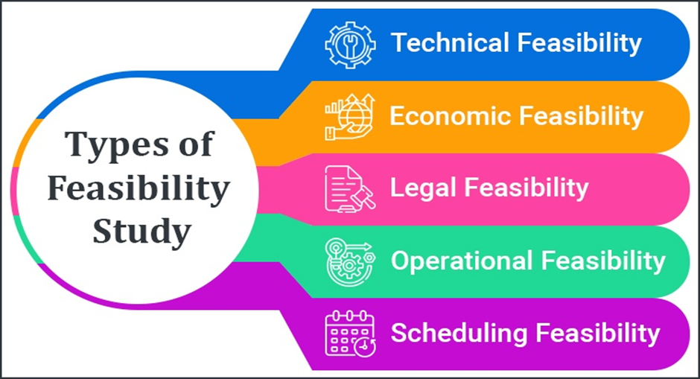
Fig 4.1.1

4.1 TYPES OF FEASIBILITY STUDY
4.1.1 Technical feasibility
A technical feasibility study reviews the technical resources available for your project. This study determines if you have the right equipment, enough equipment, and the right technical knowledge to complete your project objectives. For example, if your project plan proposes creating 50,000 products per month, but you can only produce 30,000 products per month in your factories, this project isn’t technically feasible.
4.1.2 Financial feasibility
Financial feasibility describes whether or not your project is fiscally viable. A financial feasibility report includes a cost-benefit analysis of the project. It also forecasts an expected return on investment (ROI) and outlines any financial risks.

4.1.3 Market feasibility
The market feasibility study is an evaluation of how your team expects the project’s deliverables to perform in the market. This part of the report includes a market analysis, a market competition breakdown, and sales projections.

4.1.4 Operational feasibility

An operational feasibility study evaluates whether or not your organization is able to complete this project. This includes staffing requirements, organizational structure, and any applicable legal requirements.

4.1.5 Legal feasibility
A legal feasibility analysis assesses whether the proposed project complies with all relevant legal requirements and regulations. This includes examining legal and regulatory barriers, necessary permits, licenses, or certifications, potential legal liabilities or risks, and intellectual property considerations.

4.2 SDLC Model
SDLC is a process followed for software building within a software organization. SDLCconsists of a precise plan that describes how to develop, maintain, replace, and enhance specific software. The life cycle defines a method for improving the quality of software and the all-around development process.SDLC specifies the task(s) to be performed at various stages by a software engineer or developer.
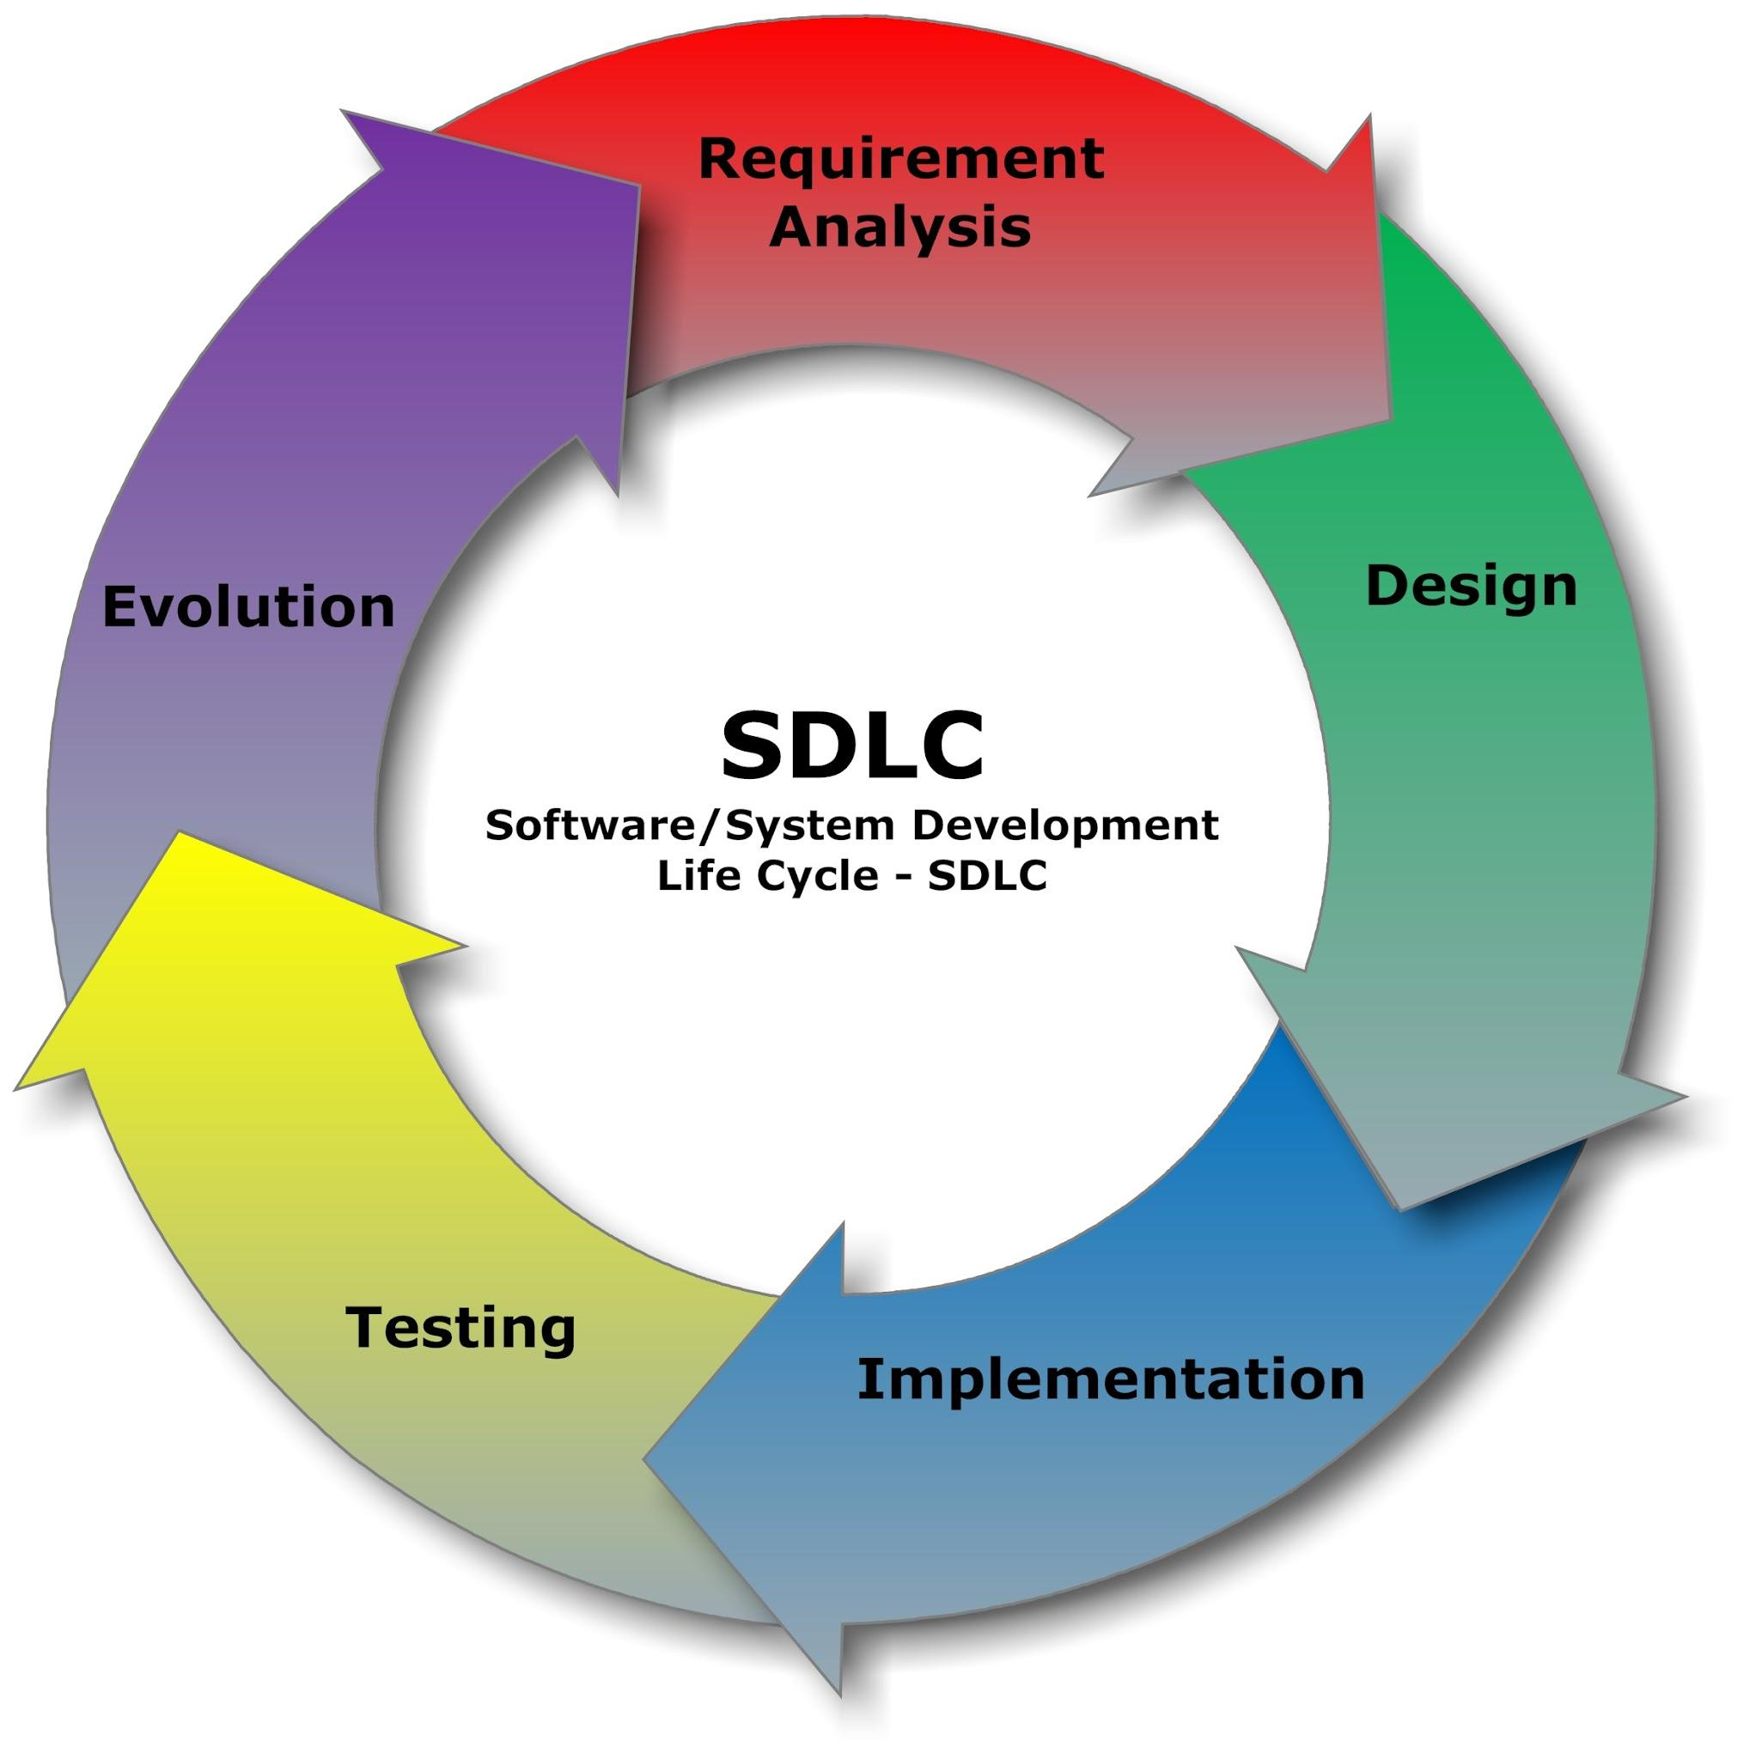
Fig 4.2.1

Stage-1: Planning and Requirement Analysis
Planning is a crucial step in everything, just as in software development.In this same stage,requirement analysis is also performed by the developers of the organization. This is attained from customer inputs, and sales department/market surveys.The information from this analysis forms the building blocks of a basic project.

Stage-2: Defining Requirements
In this stage, all the requirements for the target software are specified. These requirements get approval from customers, market analysts and stakeholders. This is fulfilled by utilizing SRS
(Software Requirement Specification). This is a sort of document that specifies all those things that need to be defined and created during the entire project cycle.

Stage-3: Designing Architecture
SRS is a reference for software designers to come up with the best architecture for the software.Hence, with the requirements defined in SRS, multiple designs for the product architecture are present in Design Document Specification (DDS). After evaluating all the possible factors, the most practical and logical design is chosen for development.

Stage-4: Developing Product
At this stage, the fundamental development of the product starts. For this, developers use a specific programming code as per the design in the DDS .Conventional programming tools like compilers, interpreters, debuggers, etc. are also put into use at this stage. Some popular languages like C/C++, Python,Java, etc. are put into use as per the software regulations.

Stage-5: Product Testing and Integration
After the development of the product, testing of the software is necessary to ensure its smooth
execution. Although, minimal testing is conducted at every stage of SDLC A well-written document acts as a tool and means to information repository necessary to know about software processes, functions, and maintenance.

Stage 6: Deployment and Maintenance of Products
After detailed testing, the conclusive product is released in phases as per the organization’s
strategy. Then it is tested in a real industrial environment. It is important to ensure its smooth
performance. If it performs well, the organization sends out the product as a whole. After
retrieving beneficial feedback, the company releases it as it is or with auxiliary improvements
to make it further helpful for the customers.

CHAPTER-5
SYSTEM REQUIREMENT SPECIFICATION
The System Requirements Specification (SRS) is a document focused on what the software needs to do and how it must perform. It lays the important groundwork so that every person involved with the project understands the most crucial details.
An SRS outlines the behaviors,functions and capabilities required of the system, along with any potential constraints. Functional and non-fu requirements are included. Design suggestions and information outside the customer’s requirements are not included.
Approval is received from all necessary stakeholders, showing that they clearly understand the project requirements and everyone agrees. In a sense, the SRS functions as an insurance policy that any party can refer to in case of uncertainty.

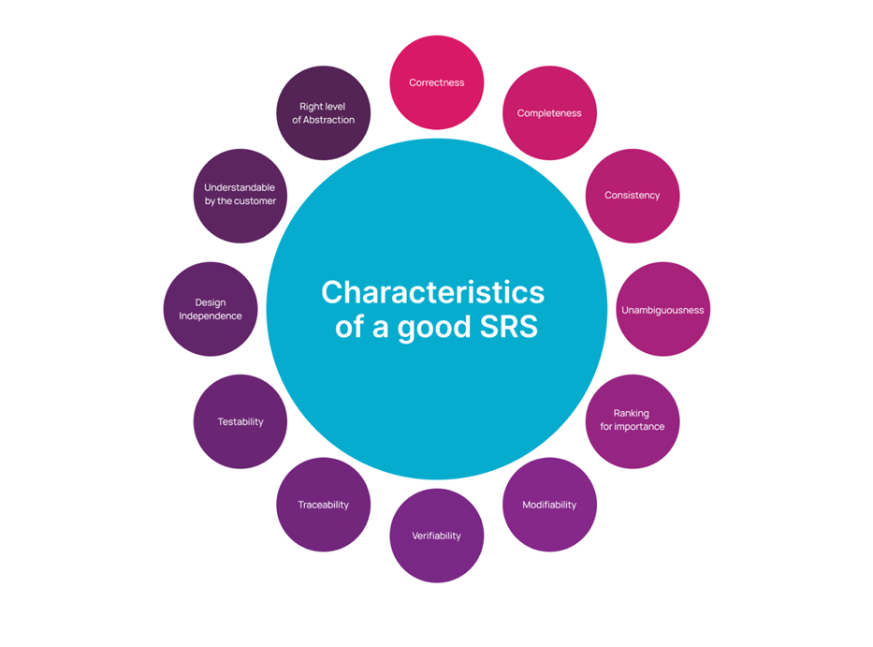
Fig 5.1.1

5.1 Need Of System Requirements Specification
Using an SRS ensures that specifics around a project are crystal clear, reducing the risk of rework and wasted time. Important benefits of using this type of document include:
Providing Valuable Customer Feedback. An SRS is the customer’s confirmation that your organization understands the problems that need to be solved and how the software must behave to address the challenges. Visuals such as charts and tables can provide additional clarity.

Breaking Work Into Smaller Pieces. An SRS contains a large amount of information, but they ultimately break problems into smaller, more manageable parts.

Serving as a Parent Document. The SRS serves as a parent document to any additional documents that follow its creation. The scope of work, software design specifications, and other documents often leverage what is highlighted in the SRS. Plus, it can serve as a product validation check. Did we do it right? Check the SRS.

Enhanced Collaboration. Software development requires collaboration. The SRS has team spirit Working together with cross-functional teams, it forms a single vision and shared understanding of the project. As a result, the development process becomes more integrated and efficient.
5.2 RESOURCES NEEDED
Resources are the requirement of the system. It can also be defined as the environment within which a system can work efficiently. In order to implement the proposed system, the following various hardware and software requirements to achieve good performance:
- HARDWARE REQUIREMENTS: -
○ Processor i5 processor system or higher
○ RAM 8 Image Creator from Microsoft Designer (bing.com )GB or higher
○ ROM 100 GB or higher
○ Windows Windows7 or higher
- SOFTWARE REQUIREMENTS: -
○ Browser- Mozilla Firefox/Chrome/Edge
○ Operating System- Windows Operating System/Linux
○ Text Editor- Visual Studio Code
5.3 TOOL USED
- PYTHON
- MATPLOTLIB
- LIBROSA
- NUMPY
- TENSORFLOW
- PANDAS
- SEABORN

CHAPTER-6
DATA FLOW DIAGRAMS(DFD’S)
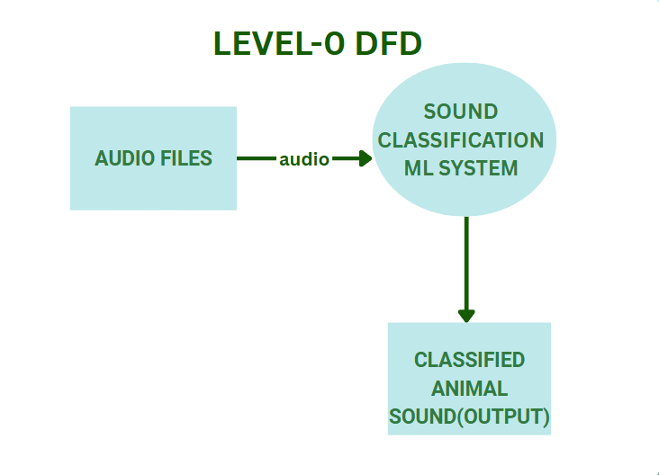
Fig 6.1

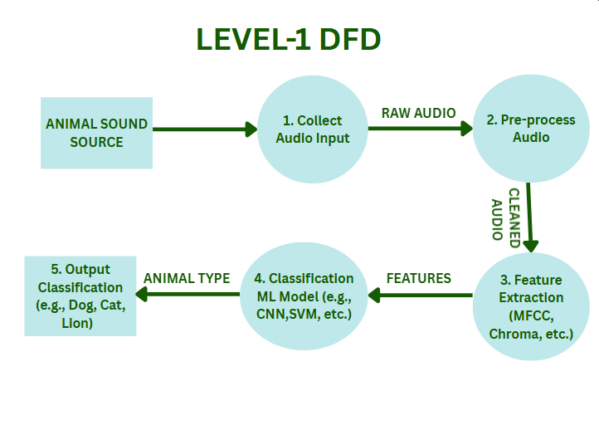
Fig 6.2

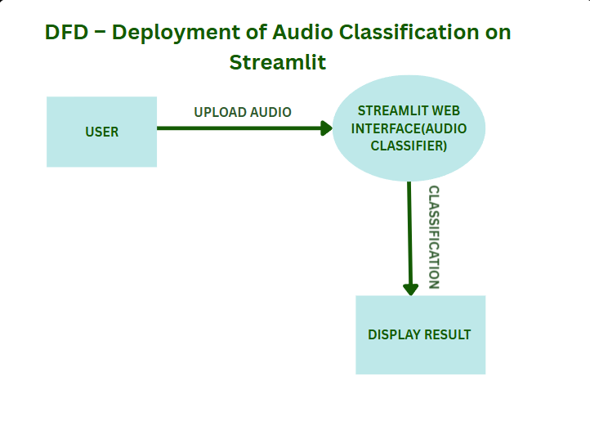

Fig 6.3

CHAPTER-7
TOOLS, TECHNOLOGIES AND LIBRARIES

7.1 TECHNOLOGIES
1.PYTHON

In the late 1980s, history was about to be written. It was that time when working on Python started. Soon after that, Guido Van Rossum began doing its application-based work in December of 1989 at Centrum Wiskunde & Informatica (CWI) which is situated in the Netherlands.
Python is a set of instructions that we give in the form of a Program to our computer to perform any specific task. It is a Programming language having properties like it is interpreted, object-oriented and it is high-level too. Due to its beginner-friendly syntax, it became a clear choice for beginners to start their programming journey. The major focus behind creating it is making it easier for developers to read and understand, also reducing the lines of code.
As an interpreted language, Python code is executed line by line, which facilitates rapid development and debugging. Its dynamic typing allows variables to change types, offering flexibility in coding. Python's object-oriented features support encapsulation, inheritance, and polymorphism, enabling developers to create complex, modular programs.



Fig 7.1.1

Characteristics of Python:
1. Simple and Easy to Learn: Python has a clean and straightforward syntax,
making it easy for programmers to grasp concepts quickly. Its readability reduces the cost of program maintenance and development.

2. Interpreted Language: Python is an interpreted language, meaning that code
written in Python is executed line by line, making the development process more agile and allowing for easier debugging.

3. High-level Language: Python abstracts low-level details, allowing programmers to focus on solving problems rather than worrying about system-level management.

4. Dynamic Typing: Python uses dynamic typing, where the type of a variable is determined at runtime. This makes Python flexible and versatile, but it also requires careful attention to variable types in large projects.

5. Multi-Programming: Python supports multiple programming, including
procedural, object-oriented, and functional programming. This versatility allows
developers to choose the best approach for solving a particular problem.

6.Platform Independent: Python code can run on various operating systems,including Windows, macOS, and Linux, without modification. This platform independence enhances its portability and makes it suitable for cross-platform development.
Features of Python:

- Embeddable
- Python can be used within C/C++ program to give scripting
capabilities for the program’s users.
- Robust
- Exceptional handling features.
- Memory management techniques in built.

2. INTRODUCTION TO IDE
An Integrated Development Environment (IDE) is a software application that provides comprehensive facilities to computer programmers for software development. It typically includes a source code editor, build automation tools, and a debugger, along with other features that streamline the development process.

Some popular IDEs for Python development include
1. PyCharm: PyCharm is a powerful Integrated Development Environment (IDE) developed by JetBrains specifically for Python development. It offers a comprehensive set of features designed to enhance productivity and streamline the development process for Python programmers.
2. Spyder: Spyder is an open-source Integrated Development Environment (IDE) specifically designed for scientific computing and data analysis with Python. Developed by the Spyder Project, it provides a powerful set of tools tailored to the needs of scientists,engineers, and data analysts.
3. Visual Studio Code: Visual Studio Code (VS Code) is a lightweight, open-source code editor developed by Microsoft. While it's not a full-fledged IDE like PyCharm, it offers many features that make it a powerful tool for Python development.

7.2 LIBRARIES

1. Pandas
Pandas is a powerful, open-source data manipulation and analysis library for Python. Created by Wes McKinney in 2008 and released publicly in 2009, pandas has become an essential tool in the data science ecosystem, bridging the gap between the scientific computing capabilities of NumPy and the flexible data manipulation requirements of data analysis.
At its core, pandas provides two primary data structures: Series (one-dimensional) and DataFrame (two-dimensional). The DataFrame, in particular, has become ubiquitous in data analysis, offering a tabular, spreadsheet-like data structure with labeled axes (rows and columns).
Pandas excels in handling various data formats. It can read and write data from multiple sources, including CSV, Excel, JSON, SQL databases, and more. This flexibility makes it invaluable for data ingestion and preparation tasks, often the most time-consuming parts of data analysis projects. The loc and iloc indexers provide intuitive ways to access data by label or position, respectively.
Time series functionality is another strength of pandas.Pandas integrates seamlessly with other libraries in the Python data science stack. It works well with NumPy for numerical computing, Matplotlib and Seaborn for visualization, and scikit-learn for machine learning. This interoperability allows for end-to-end data science workflows within the Python ecosystem.The library's handling of missing data is sophisticated, offering various strategies for dealing with NaN (Not a Number) values. Methods for filling, dropping, or interpolating missing data provide flexibility in addressing this common challenge in real-world datasets.

Pandas also provides powerful tools for data aggregation and analysis. The group by functionality allows for split-apply-combine operations, essential for summarizing and analyzing data across categories.
One of pandas' strengths is its ability to handle messy, real-world data. Functions for data cleaning, such as removing duplicates, replacing values, and renaming columns, make it easier to prepare data for analysis. The melt and pivot functions allow for easy conversion between wide and long data formats, accommodating different analytical needs.

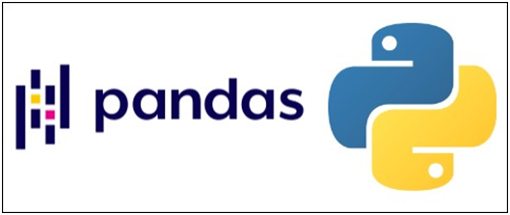

Fig 7.2.1

2. Numpy

NumPy (Numerical Python) is a fundamental package for scientific computing in Python. Created by Travis Oliphant in 2005, it evolved from earlier packages like Numeric and Numarray. NumPy has become the foundation of the Python scientific computing stack, providing powerful tools for handling large, multi-dimensional arrays and matrices, along with a vast collection of high-level mathematical functions.

At the core of NumPy is the ndarray (n-dimensional array) object, a fast, flexible container for large datasets in Python. Unlike Python's built-in lists, NumPy arrays are homogeneous (all elements must be of the same type) and offer significant performance improvements for numerical operations.

NumPy's array operations are vectorized, meaning they can be applied to entire arrays without explicit loops. This vectorization not only makes code more concise and readable but also significantly boosts performance, especially for large datasets. Operations that might take hundreds
of lines in pure Python can often be expressed in a few lines with NumPy, running orders of magnitude faster.The library provides a comprehensive set of mathematical functions for array operations. These include basic arithmetic operations, trigonometric functions, exponential and logarithmic functions,
and statistical operations. NumPy also offers tools for linear algebra, including matrix operations, eigenvalue problems, and solving systems of linear equations.
One of NumPy's strengths is its broadcasting capability. This feature allows operations on arrays of different shapes, automatically replicating smaller arrays across larger ones. Broadcasting simplifies code and improves memory efficiency by avoiding unnecessary copies of data. NumPy's indexing and slicing operations are powerful and flexible. They allow for complex data selection and manipulation, including boolean indexing, which enables sophisticated filtering of data based on conditions.
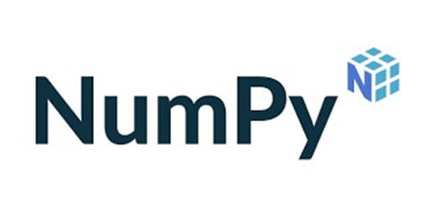
Fig 7.2.2
3. Matplotlib:

Matplotlib is a plotting library for Python and its numerical mathematics extension NumPy. Created by John D. Hunter in 2003, Matplotlib has become the foundational library for data visualization in the Python ecosystem. It provides a MATLAB-like interface for creating a wide variety of static, animated, and interactive visualizations.

At its core, Matplotlib offers two primary interfaces: a MATLAB-style state-based interface (pyplot) and an object-oriented interface. The pyplot interface is designed for simple plotting tasks and closely mimics MATLAB's plotting commands, making it easy for users familiar with MATLAB to transition to Python. The library supports a vast array of plot types, including line plots, scatter plots, bar charts, histograms, pie charts, stem plots, contour plots, 3D plots, and many more.This versatility makes Matplotlib suitable for a wide range of scientific and statistical visualizations. One of Matplotlib's strengths is its customization capabilities

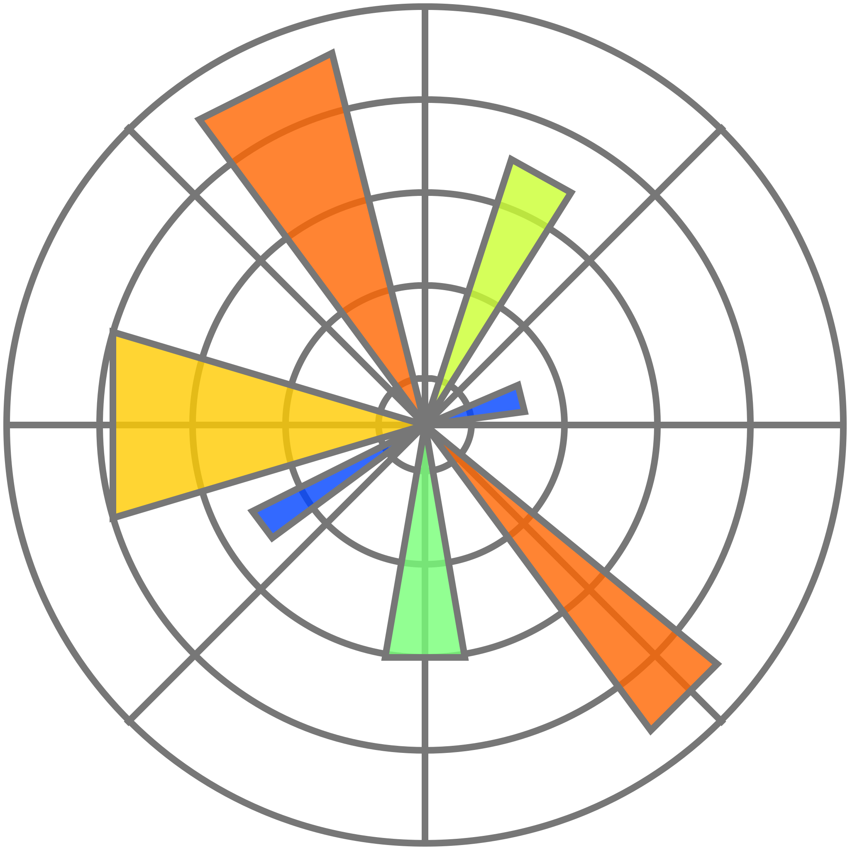
Fig 7.2.3

Matplotlib integrates seamlessly with NumPy and can work directly with NumPy arrays. This integration extends to other libraries in the scientific Python ecosystem, such as pandas and SciPy, allowing for easy visualization of data from these sources. Recent developments in Matplotlib have focused on improving performance, enhancing 3D plotting capabilities, and providing better support for large datasets. Matplotlib's influence extends beyond direct usage. It serves as the foundation for higher-level plotting libraries like Seaborn, which provides a more user-friendly interface for statistical graphics, and has inspired the design of other visualization libraries in the Python ecosystem.

7.3 TOOLS

1.LIBROSA

Librosa is a powerful Python library that offers a wide range of tools and functionalities for handling audio files. Whether you’re a music enthusiast, a data scientist, or a machine learning engineer, Librosa can be a valuable asset in your toolkit. In this hands-on guide, we will explore the importance of Librosa for audio file handling and its benefits and provide an overview of the library itself.

Audio file handling is crucial in various domains, including music analysis, speech recognition, and sound processing. Librosa simplifies working with audio files by providing a high-level interface and a comprehensive set of functions. It allows users to perform audio data preprocessing, feature extraction, visualization, analysis, and even advanced techniques like music genre classification and audio source separation.
Librosa is built on top of NumPy and SciPy, which are fundamental libraries for scientific computing in Python. It provides a set of modules and submodules that cater to different aspects of audio file handling. Some of the key modules include:
- Core: This module contains the core functionality of Librosa, including functions for loading audio files, resampling, and time stretching.
- Feature Extraction: This module extracts audio features such as mel spectrogram, spectral contrast, chroma features, zero crossing rate, and temporal centroid.
- Visualization: As the name suggests, this module provides functions for visualizing audio waveforms, spectrograms, and other related visualizations.

- Effects: This module offers functions for audio processing and manipulation, such as time and pitch shifting, noise reduction, and audio segmentation.

Feature Extraction is a crucial step in audio analysis, as it helps capture the audio signal’s relevant characteristics. Librosa offers various functions for extracting audio features, such as mel spectrogram, spectral contrast, chroma features, zero crossing rate, and temporal centroid. These features can be used for music genre classification, speech recognition, and sound event detection.


Fig 7.3.1

2.TENSORFLOW

TensorFlow is an open-source software library for machine learning, widely used for developing and deploying machine learning models. It provides a comprehensive ecosystem of tools, libraries, and resources to support the entire machine learning workflow, from data preparation to model deployment. TensorFlow's flexibility allows it to be used in various applications, including image recognition, natural language processing, and more.

7.2.1 Key Concepts
- Data Flow Graph: Tensorflow represents computation as data flow graphs, where nodes are mathematical operations and edges are tensors(multi-dimesional arrays).
- Tensors: Tensors are the core data structures in Tensorflow, representing data as multi-dimensional arrays.
- Automatic Differentiation: Tensorflow includes automatic differentiation,which is crucial for training machine learning models using algorithms like gradient descent.
- Flexibility and Scalability: Tensorflow can be used on various hardware platforms(CPU,GPUs,TPUs) and operating systems,making it suitable for different deployment.
7.2.2 How it Works:
- Data Preparation: Tensorflow provides tools for data cleaning, transformations and preprocessing.
- Model Building: You define your machine learning model using TensorFlow’s APIs,specifying the architecture and operations.
- Training: TensorFlow optimizes your model by adjusting its parameters based on the training data.
- Deployment: TensorFlow allows you to deploy your trained models on various platforms,including web browsers,mobile devices,and edge devices.

3. STREAMLIT
Streamlit is an open-source Python library that simplifies the creation of web applications for data science and machine learning projects. Launched in 2019, Streamlit has quickly gained popularity among data scientists and developers for its ability to turn data scripts into shareable web apps with minimal effort.At its core, Streamlit allows users to create interactive, data-driven web applications using pure Python code. This approach eliminates the need for front-end development skills typically required for web application development, such as HTML, CSS, or JavaScript. Instead, developers can focus on their data analysis and visualization code, while Streamlit handles the web interface generation.
Streamlit's architecture is designed for simplicity and rapid development. When a Streamlit script is run, it generates a web application where each variable or function creates a user interface element. The library provides a wide range of UI components, including text inputs, buttons, sliders, and file uploaders, which can be easily integrated into the app with just a few lines of code.

For data visualization, Streamlit seamlessly integrates with popular Python libraries such as Matplotlib, Plotly, and Altair. This allows developers to create complex, interactive charts and graphs within their streamlit apps. The library also supports the display of multimedia including images ,videos and audio files
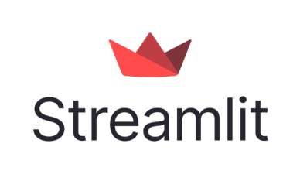
Fig 7.3.2
CHAPTER-8
IMPLEMENTATION, TESTING AND MAINTENANCE
8.1 IMPLEMENTATION
1. Data Collection
- Gather audio datasets of different animal species(e.g., from Kaggle,Google Audio Set,or field recordings).
- Ensure the data is labelled(e.g., “dog”, “cow”, “elephant”, etc).
2. Data Preprocessing
- Convert audio formats (e.g., .wav, .mp3) to a standard format.
- Trim silence and normalize audio length.
- Extract features such as:
  - MFCC(Mel-Frequency Cepstral Coefficients).
  - Spectrograms or Mel Spectrograms.
  - Chroma features, Zero-Crossing Rate etc.
3. Feature Extraction
- Use libraries like Librosa or Tensorflow Audio to extract audio features.
- Transform audio signals into 2D feature representations(for CNN models).
4. Model Selection & Training
- Choose suitable ML/DL algorithm such as:
- CNN(Convolutional Neural Network): For spectrogram image classification.
- RNN/LSTM: For time-series audio data.
- Random Forest/SVM: For tabular features like MFCCs.
- Split the dataset into training, validation , and test sets.
- Train the model using frameworks like Tensorflow,keras or PyTorch.

5.Model Evaluation
- Evaluate model using metrics:
- Accuracy, Precision,Recall,F1-Score
- Confusion matrix to check class-wise performance
- Use validation set to fine-tune hyperparameters.
6.Deployment(Optional)
- Deploy using Streamlit,Flask or FastAPI for a user interface.
- User uploads an audio fileModel processes itDisplays predicted animal class.
8.2 Introduction of Testing
During testing the program to be tested is executed with the set of test cases and the output of the program for the test cases is evaluated to determine if the program is performing as expected. Due to its approach dynamic testing can only ascertain the presence of errors in the program, the exact nature of errors is not usually decided by testing.
Once a program is tested individually then the system as a whole needs to be tested. During testing the system is used experimentally to ensure that the software does not fail i.e. it will run according to its specification. The programs are executed to check for any syntax and logical errors. The Errors are corrected and a test is made to determine whether the program is doing what it is supposed to do.
8.2.1 Developing a Test Plan
The first step in testing is developing a test plan based on the product requirements. The test plan is usually a formal document that ensures the product meets the following standards:
● Is thoroughly tested: Untested code adds an unknown element to the product and increases the risk of product failure.
● Meets product requirements: To meet customer needs, the product must provide the features and behavior described in the product specification. For this reason, specifications should be clearly written and well understood. product
● Does not contain defects: Features must work within established quality stand and those standards should be clearly stated within the test plan.
8.2.2 TYPES OF TESTING
The test plan specifies the different types of tests that will be performed to ensure the product meets customer requirements and does not contain defects. Table 10-1 describes the most common test types.
Test type | Ensure that
Unit test: | Each independent piece of code works correctly
Integration test: | All units work together without errors
Regression test: | Newly added features do not introduce errors to other features that are already working
Load test (also stress test): | The product continues to work under extreme usage
Platform test: | The product works on all of the target hardware and software platform

8.2.8 TEST PLANNING
The test planning stage represents the need to review long–lead-time test planning activities.During this phase, the test team identifies test procedure creation standards and guidelines The test plan contains the results of each preliminary phase of the structured test methodology (ATLM). The test plan will define roles and responsibilities, project test schedule, test planning and design activities, test environment preparation, test risks and contingencies, and acceptable level of thoroughness (test acceptance criteria).
The test environment setup is part of test planning. It represents the need to plan, track, and manage test environment setup activities, where material procurements may have long lead times. The test team needs to schedule and track environment setup activities; install test environment hardware, software, and network resources; integrate and install test environment resources; obtain/refine test databases; and develop environment setup scripts and test bed scripts.
8.2.9 TEST DESIGN
The test design component addresses the need to define the number of tests to be performed, the ways that testing will be approached (paths, functions), and the test conditions that need to be exercised. Test design standards need to be defined and followed.
An effective test program, incorporating the automation of software testing, involves a mini- development lifecycle of its own, complete with strategy and goal planning, test requirement definition, analysis, design, and coding. Similar to software application development, test requirements must be specified before test design is constructed. Test requirements are defined within requirement statements as an outcome of test requirement analysis. After test requirements have been derived using the described techniques, test procedure.
8.3 MAINTENANCE
❖ Bug Fixes: Address and resolve any issues or bugs identified during testing or reported by users. Prioritize and fix bugs promptly to maintain system reliability and user satisfaction.
❖ Updates and Enhancements: Continuously improve the system by implementing new features, enhancements, and optimizations based on user feedback and emerging requirements. Prioritize updates based on user needs and market trends.
❖ Performance Optimization: Monitor and optimize the system's performance over time to ensure efficient resource utilization, minimize latency, and improve overall responsiveness.
❖ Security Updates: Stay vigilant against security threats and vulnerabilities by applying security applying security updates, patches, and fixes to the system. Regularly review and update security measures to mitigate risks and protect user data.
❖ Documentation: Keep system documentation up-to-date, including user manuals, guides, and technical documentation. Document changes, updates, and enhancements to help users and developers understand the system's functionality and usage.

CHAPTER-9
SCREENSHOTS
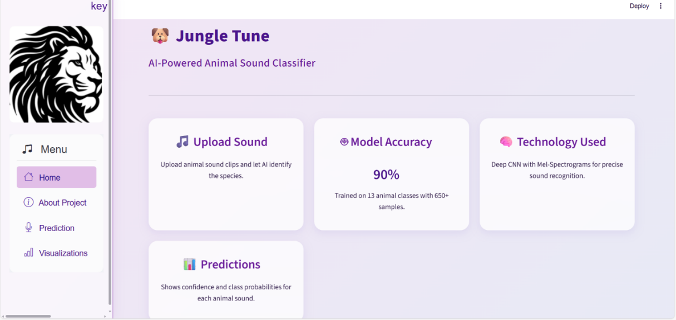
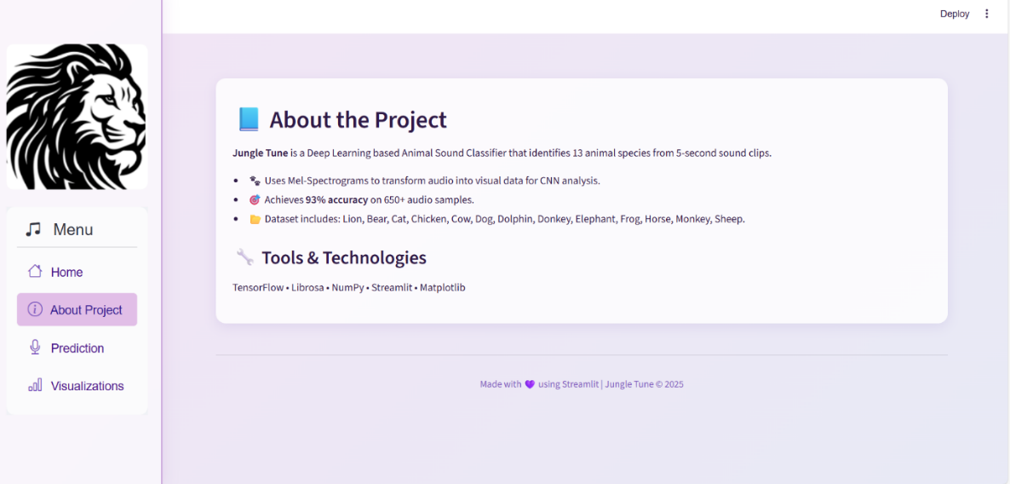
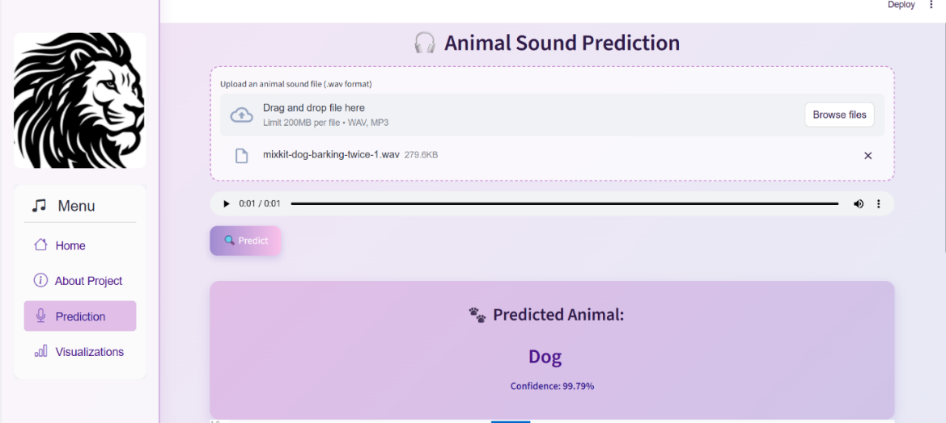
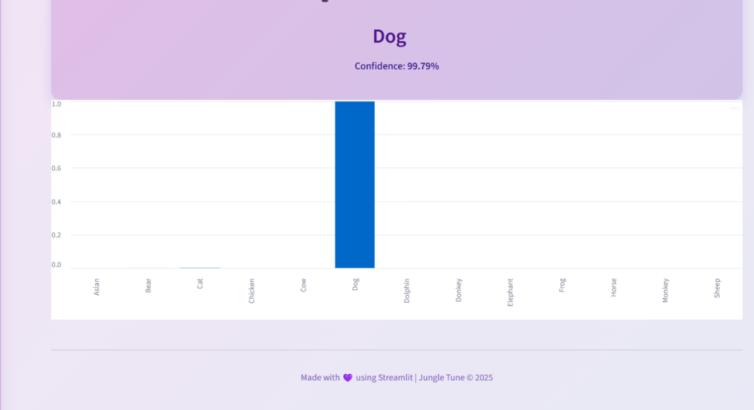
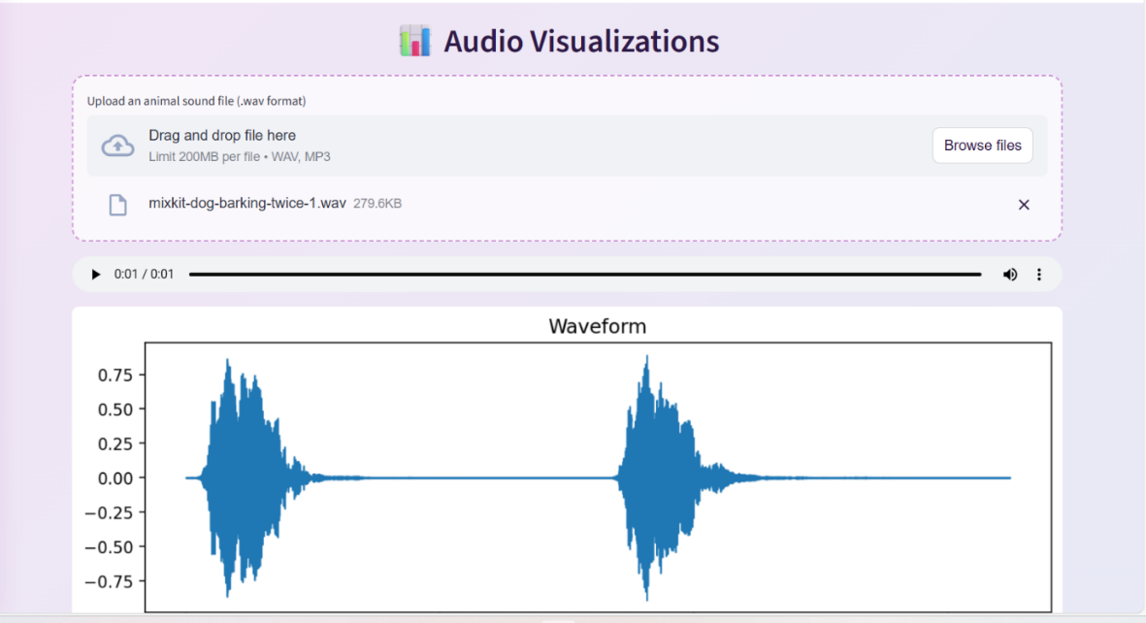
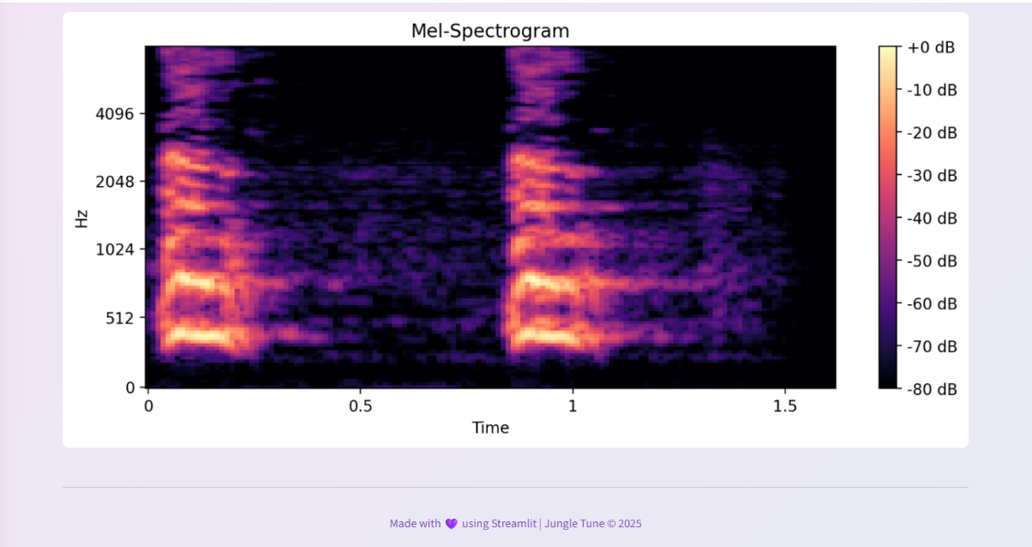
CHAPTER-10
CONCLUSION AND FUTURE SCOPE

CONCLUSION
Sound classification of animal voice using machine learning and AI is a powerful and efficient approach to identifying and analyzing animal sounds . It enables automatic recognition of animal species based on their vocal patterns,which is useful in wildlife monitoring ,environmental research ,smart farming , and conservation efforts,protect from predators and detect distress level etc.By extracting audio features and training machine learning models,we can accurately classify complex and noisy sounds.This supports real-time applications.

In conclusion, sound classification of animal voice using ML is not just a technical achievement—it’s a meaningful contribution to biodiversity preservation, ecological research, and intelligent environmental monitoring. With growing interest in eco-friendly technologies, such models hold immense potential for real-world impact.

FUTURE SCOPE
1. Animal Emotion Recognition
- Detect not just the species,but the emotional state(e.g.,fear,hunger)from voice alone.
2. Image Recognition
- By using CNN models we will detect and recognize images from detected animal voice/audio.
3. Self-Learning Systems
- Future ML systems will learn from new sounds on their own.
- Can discover unknown species or learn new animal behaviors without explicit labeling.
4.Autonomous Wildlife drones
- Deploy flying drones equipped with mics+ML to detect and follow animals by their vocalizations in dense forests.
5.AI-Assisted Bioacoustics Databases
- Creation of large, global sound libraries for research and environmental monitoring.

BIBLIOGRAPHY
- To Find Python and IDE Use:
https://www.geeksforgeeks.org/python/python-programming-language-tutorial/
- To read libraries(Numpy,Matplotlib,Pandas,Seaborn):
https://www.almabetter.com/bytes/tutorials/python/popular-python-libraries
- To read tools (Pytorch,Tensorflow):
https://www.geeksforgeeks.org/python/difference-between-pytorch-and-tensorflow/
- To read documentary of Streamlit:
https://www.geeksforgeeks.org/python/a-beginners-guide-to-streamlit/
- To read documentary of Librosa:
https://www.analyticsvidhya.com/blog/2024/01/hands-on-guide-to-librosa-for-handling-audio-files/

